CS 534 EX2 ------- Xiao Tan

Part I: Reflections from HW1

----------------------------

0. Kaiwen Zheng, Haoyu Zhang, Xiao Tan

1. Discuss solutions with teammates, write part of report, and part of code.

2. have made.

3. I think include those not observed will be better. Because even train set could large, it may not include every case in this mode. Those unobserved case just have a very low possibility, not mean that they are not exist.

4.(a) underfitting

(b) Yes, it is.

(c) predict 100% will be better. Like negative examples are 75%, Based on p2+(1-p)2, when we assume it 100% negative, the negative possibility could be 75% . then, assume it 75% negative, it will be 75%*75%+25%*(1-75%) = 62.5% < 75%. so predict 100% negative will be better.

(d) Our mode bias is -5, and Doctoral degree is 64, so it can be bias.

5.

(a)

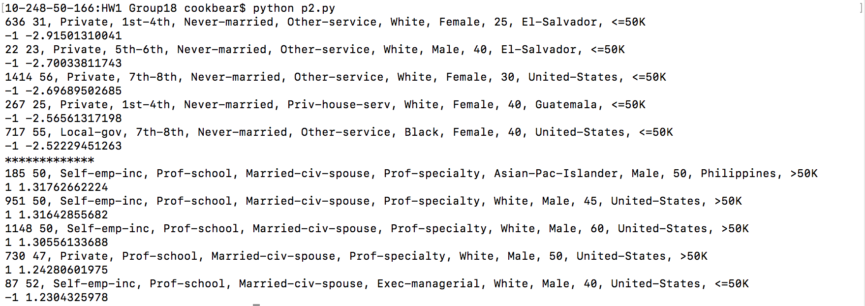

(b)

Only the last predict is incorrect.

(c)

the most positive: the most negative one:

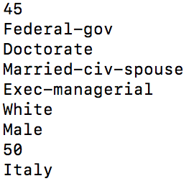 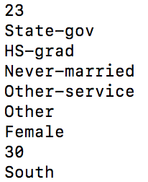

(d)

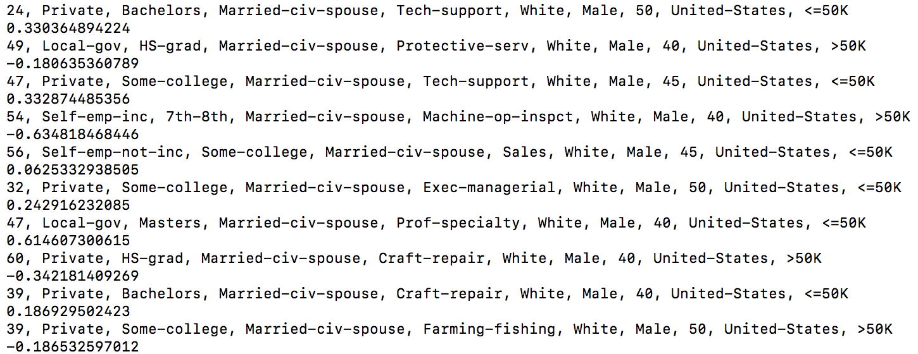

Part II: SVM Theory

-------------------

1.

*(a) maximize geometric margin*

*(b) minimize weight norm*

2.

*(a) if we replace the minimum functional margin of 1 by 10*

Length of weight norm will be changed to 10 times.

*(b) if we require the geometric margin to be at least 1*

We can’t. because it depends on feature mapping, we can’t decide produces of geometric margin.

3.

At most d+1, d is dimensions.

4.

a) F

maybe not a SVM mode. Even it is a SVM mode, it could be on the margin but not in support vector set.

b) T

it is true.

5.

a) convex hull will be very hard to compute in high dimension;

b) we don’t need to figure out a whole convex hull, only the parts near margin, convex hull will make this problem complicate.

6.

(a) one constraint is active; (b) both constraints are active.

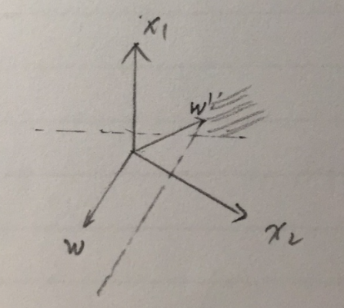 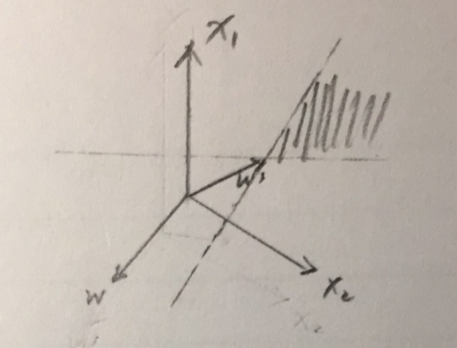

7.

2 support vectors

8.

The convex optimization easier than the general case since local minimum must be a global minimum, and first-order conditions are sufficient conditions for optimality.

9.

Not all QP instances are convex optimization, only those convex QP instances are convex optimization.

All linear programs instances are convex optimization.

SVM is SV set are convex set, and a convex problem is optimized a convex function over a convex set. So SVM is a convex problem.

10.

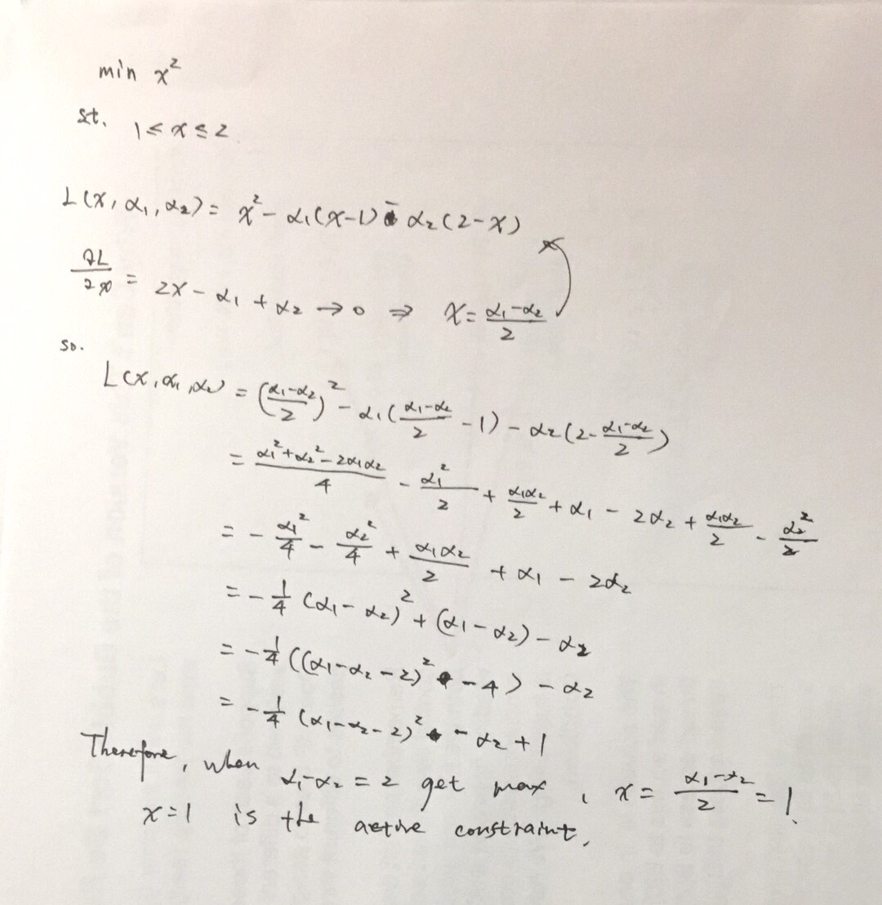

11.

There exist can make inequities conditions in KKT become equities conditions. When there are no inequality constraints, the KKT conditions turn into Lagrange conditions, so we can solve this problem with Lagrange multipliers.

DEBRIEF SECTION

1. Discuss with other students. Kaiwen Zheng

2. 8 hours

3. Difficult

4. just in right place

5. videos are really helpful for us to review.